)

SPEEDl/Nll ,10NPH
- SEEBACK FOR CANPSUERULES

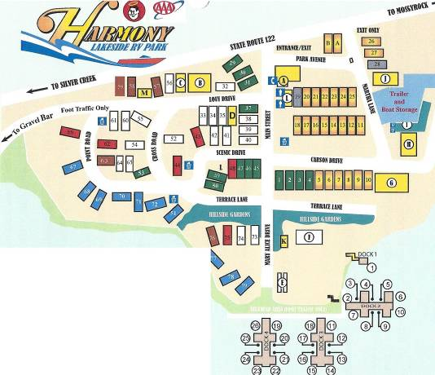@ MANAGERS OFFICE
@ RUSTIC ROOSTER
@ COFFEE BAR
@ LAUNDRY ROOM
(key in office)
@ VOLLYBALL
® HORSESHOE PIT
@ SHOP (PRIVATE
@ BARN (PRIVATE)
CD STORAGE AREA(PRIVATE )
GARAGE (PRIVATE) FISH CLEANING
MEN/WOMENS SHOWERS
® Dish Washing

